**Universal Logic Gates**

One of the main disadvantages of using the complete sets of AND, OR and NOT gates is that to produce any equivalent logic gate or function we require two (or more) different types of logic gate, AND and NOT, or OR and NOT, or all three as shown above. However, we can realize all of the other Boolean functions and gates by using just one single type of universal logic gate, the NAND (NOT AND) or the NOR (NOT OR) gate, thereby reducing the number of different types of logic gates required, and also the cost.

The NAND and NOR gates are the complements of the previous AND and OR functions respectively and are individually a complete set of logic as they can be used to implement any other Boolean function or gate. But as we can construct other logic switching functions using just these gates on their own, they are both called a minimal set of gates. Thus the NAND and the NOR gates are commonly referred to as **Universal Logic Gates**.

**Implementation of Logic Functions Using Only NAND Gates**

The 7400 (or the 74LS00 or 74HC00) quad 2-input NAND TTL chip has four individual NAND gates within a single IC package. Thus we can use a single 7400 TTL chip to produce all the Boolean functions from a NOT gate to a NOR gate as shown.

**Logic Gates using only NAND Gates**

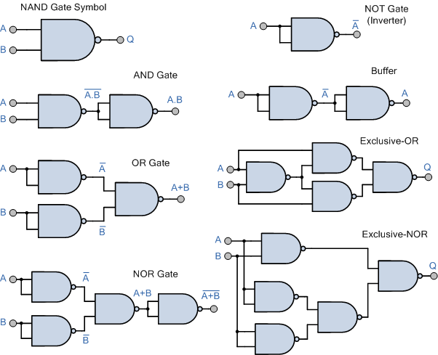

Thus ALL other logic gate functions can be created using only NAND gates making it a universal logic gate.

**Implementation of Logic Functions Using Only NOR Gates**

The 7402 (or the 74LS02 or 74HC02) quad 2-input NOR TTL chip has four individual NOR gates within a single IC package. Thus like the previous 7400 NAND IC we can use a single 7402 TTL chip to produce all the Boolean functions from a single NOT gate to a NAND gate as shown.

**Logic Gates using only NOR Gates**

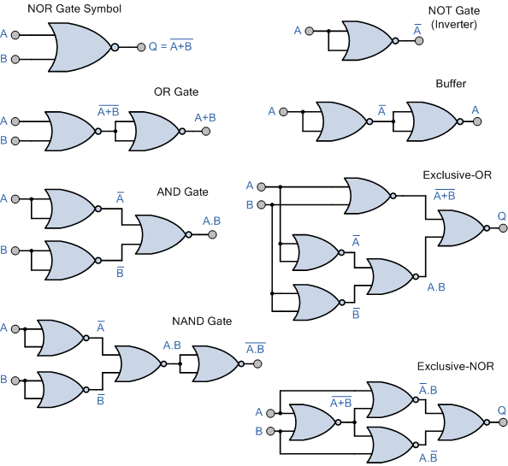

Thus ALL other logic gate functions can be created using only NOR gates making it also a universal logic gate.

Note also that the implementation of the Exclusive-OR gate is more efficient using NAND gates compared to using NOR gates, while the implementation of the Exclusive-NOR gate is more efficient with NOR gates compared to using NAND gates as in each case only four individual logic gates are required. In other words, we can create all the Boolean functions using just one 7400 NAND or one 7402 NOR chip including its various sub-families.